# Exercise: Computer Systems and Software - Visual Studio Code

Problems for exercises and homework for the ["Software Technologies" course @ Software University.](https://softuni.bg/trainings/4086/software-technologies-may-2023)

## What is it and why you need it?

**Visual Studio Code (VSC)** is a free and open-source code editor developed by Microsoft that allows developers to create and edit source code for various types of applications, including web, mobile, and desktop. It supports multiple programming languages and frameworks, such as JavaScript, Python, C#, and .NET. VSC provides a unified development environment that simplifies testing, debugging, and code analysis across multiple languages and frameworks. With its rich feature set and flexibility, VSC has become a popular choice for developers and QA engineers alike.

## How to install?

**1.** First, you will need to navigate to [**https://code.visualstudio.com/**](https://code.visualstudio.com/)

For this tutorial we are **installing Windows x64 version.**

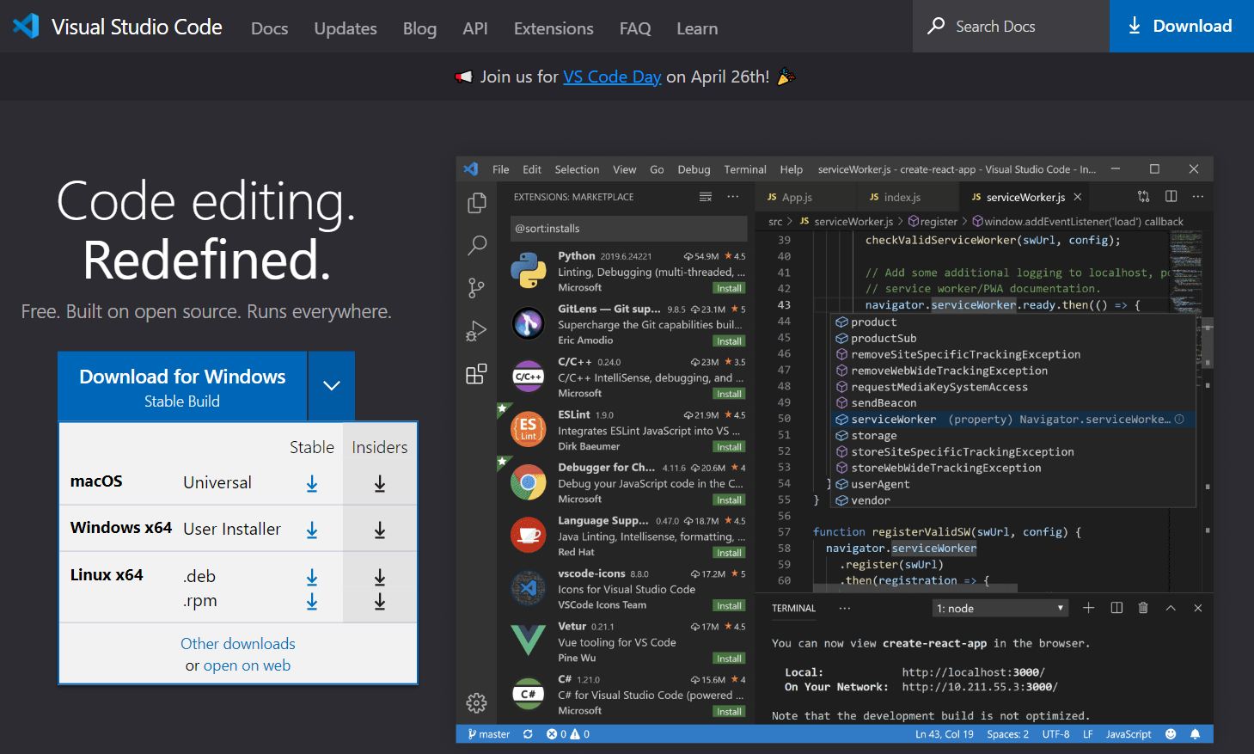

**2.** This will **download** the **installation file**.

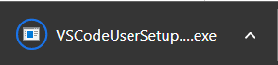

**3. Open** the .**exe file**. This will open the installer. Accept the **License Agreement** and hit **"Next".**

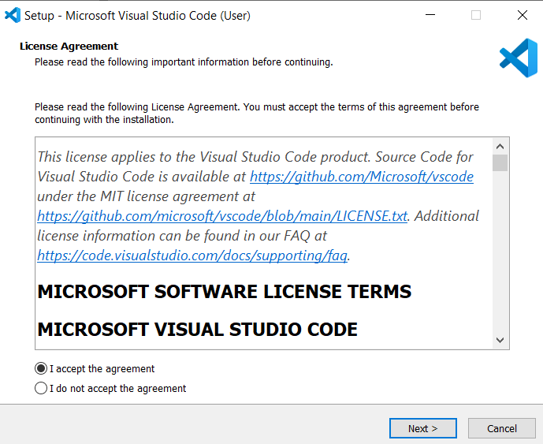

**4.** Choose **where to install. Next.**

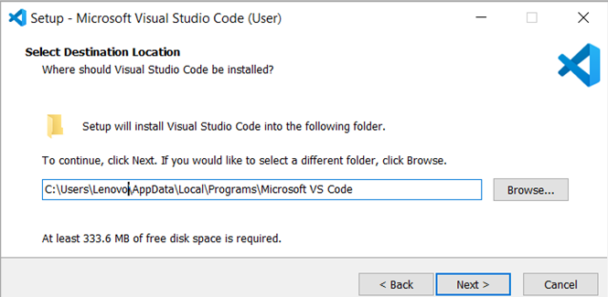

**5.** Choose where the **shortcuts in the Start menu** should be. **Next.**

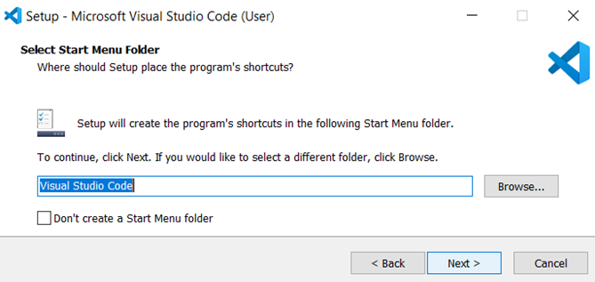

**5.** Check the pointed in red options. **Next.**

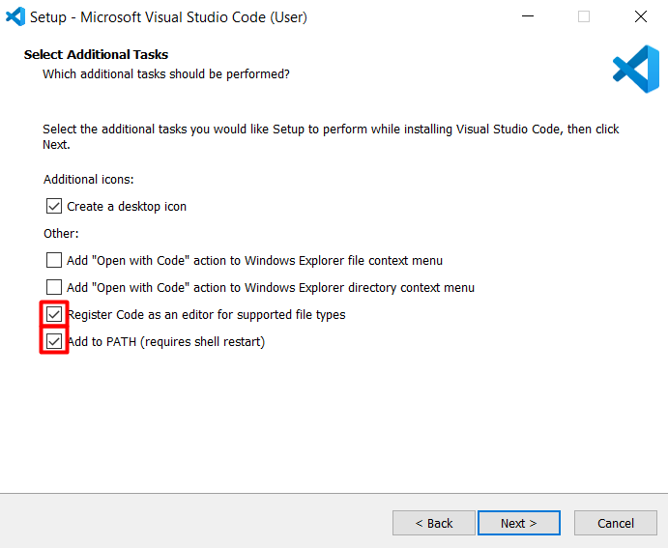

**6.** Check if everything is as expected. **Install.**  
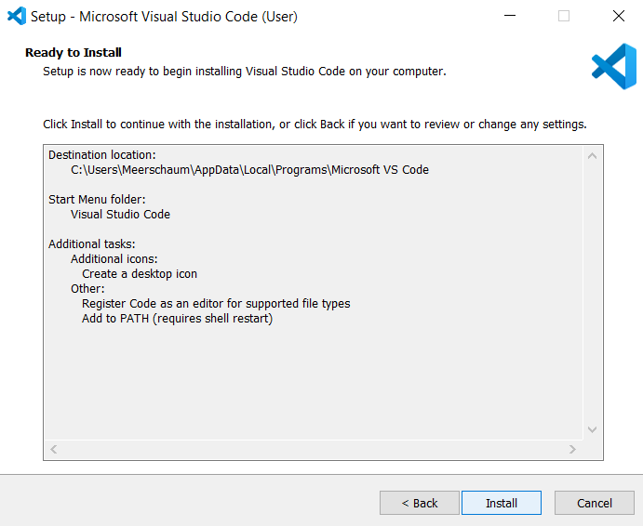

**7. Check Launch Visual Studio Code. Finish.**

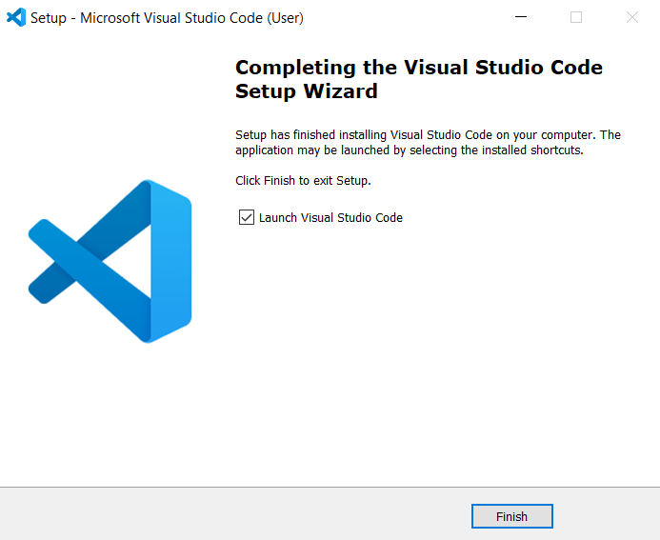

**8. This is how VSC looks like.**

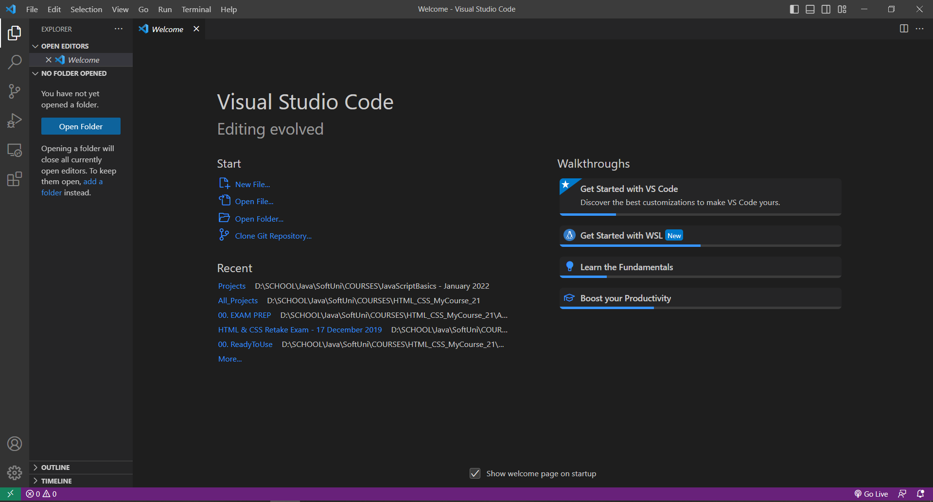

## Create a sample README.md file and preview it

1. Open VSC and create a Click on "File" in the top menu and select "New File." Name the file "README.md" and press enter. Choose where to create the file.

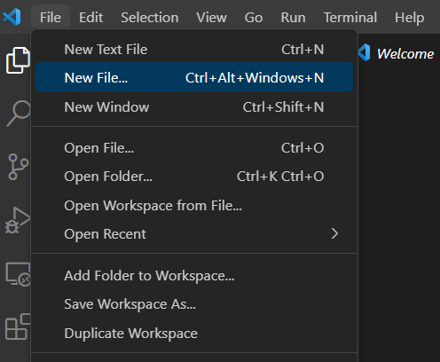

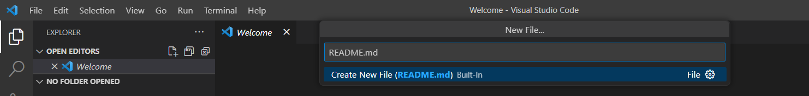

**2. Paste the following** in the file you just created or write one of your own. You can include information about your project, how to use it, and any other relevant details.

# Software Technologies

This is a sample QA course README.md

### Installation

Instructions for installing the required tools and software for the course.

### Usage

Instructions for using the sample code and exercises to practice QA testing.

### Contributing

Guidelines for contributing to the course repository.

### License

Information about the license for the course.

### Contact

Contact information for the course instructors.

### Additional Information

Any additional information or resources that may be helpful for the course.

### Credits

Acknowledgements for third-party resources used in the course.

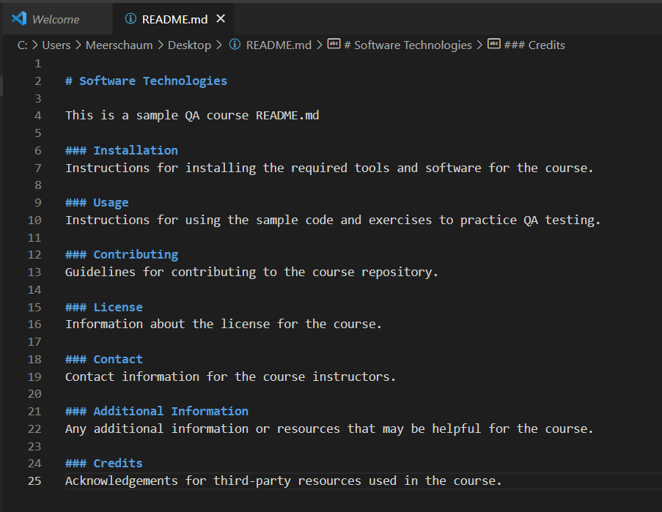

**3.** Once you've written your README.md file, you can preview it to see how it will look like. To do this, **click Ctrl + Alt + V to open the preview in a new tab.**

